Template letter for an objection to your MP
Subject: Urgent Concerns Regarding the Proposed Scout Moor II Wind Farm and its Implications for Our Constituency
Note that this template can be used with minor modifications to write to your local councillors.

Dear [MP name],
I am writing to you today as a concerned constituent and on behalf of the "Say No to Scout Moor 2" campaign, to respectfully urge you to reconsider your stance on the proposed Scout Moor 2 wind farm. I believe that this development, presented by Cubico Sustainable Investments, is deeply flawed and poses significant, irreversible harm to our cherished moorland, local communities, and the financial well-being of taxpayers.
It is imperative that the true implications of this project are understood, as we believe supporting it would be profoundly detrimental to our constituency and, respectfully, could severely damage your prospects for re-election.
We urge you to consider the following critical points, which directly contradict the developer's claims.
Misleading Energy Generation Claims and the Financial Burden on Taxpayers

Cubico claims Scout Moor II will generate up to 100MW of clean electricity – enough to power more than 100,000 homes each year.

This is a nominal rating and is misleading to the general public. The capacity factor for Scout Moor 2 is unlikely to be much above 30% so its average output will be a much less impressive 30MW. At many times it will produce nothing at all. Therefore, it could not provide any single home with electricity throughout the year. Their figure is an average which sums partial supplies to multiple homes. They can only get away with this intermittent/average supply because renewables rely on gas, nuclear and interconnectors for backup and grid stabilisation. Battery storage can only provide minimal, expensive and unsafe backup. Wind farms are effectively parasites.
Far from providing affordable energy, this project will impose a substantial financial burden on taxpayers. In summary, Cubico stand to make a profit of £13 million every year, with a public subsidy of £11 million per year. Put another way, 85% of their profit will come from us, the taxpayers. I provide the supporting profit/subsidy calculations later, but this cost is simply immoral.
Devastating and Irreversible Environmental Damage
Cubico's claim of protecting the moorland is disingenuous.
The proposal involves digging up thousands of tonnes of peat and burying many times more thousands of tonnes of concrete bases. These will never be removed. Removal of peat will increase flood risk and severely damage its ability to capture carbon. Peat takes hundreds of years to restore.
The construction of many miles of additional access tracks will facilitate illegal and anti-social off-road motor-biking.
This development poses irreparable damage to our unique heritage, including Waugh’s Well, the Cotton Famine Road and the Catley Lane Head and Prickshaw & Broadley Fold Conservation Areas.
Scout Moor 2 will endanger wildlife such as curlews (now on the red list) and skylarks, which are already in decline.
Paradoxically, due to manufacturing, transportation and construction, the wind farm could even lead to increases in carbon emissions! We know this because Cubico are using the Scottish Environmental Protection Agency (SEPA) Carbon Calculator, of which they say in section 15.5 of their application:
This methodology has been employed in the absence of a methodology that is specific onshore windfarms on peatland in England.
This is another ingenuous statement from Cubico. They know very well that not only is there no carbon calculator available for peatland in England, but SEPA have already stated that the Scottish calculator is now not appropriate for peatland. You might think this is a small distinction. However, put simply, Cubico are trying to justify their wind farm on climate change grounds by using a calculator which is already known to be unsuitable for peatland anywhere, by the authors of the calculator! [see source 3]
Minimal Local Benefit and Threat to Community Fabric

Cubico's proposed Community Wealth Fund of at least £600,000 per year or 3% of revenue, sounds substantial. However, £600,000 represents only about 5.5% of the total subsidy of £11m that Cubico will receive annually from taxpayers.

Furthermore, Scout Moor 1 accounts show zero employees as all maintenance is carried out by specialist contractors, indicating that this project will not create any meaningful long term, let alone local, jobs.

The development also poses a serious threat to the continuation of commoners exercising their rights of common, which are integral to the area’s social fabric and traditional practices. All profits will ultimately flow back into the hands of Canadian pensioners, as Cubico is owned by a Canadian Pension Fund.

Net Zero is universally unpopular
You may not be aware that climate policies meet almost universal disapproval as this chart from More in Common [source 2] shows.
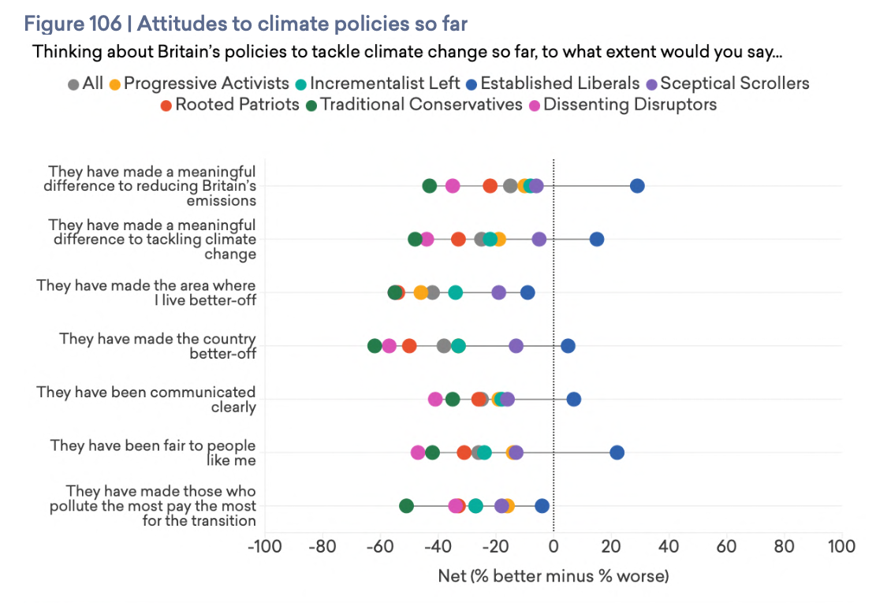
This is from a survey not about who believes in climate change, but whether climate policies work and whether they are fair. The overall result is that in every case the All response (the grey circle) is negative. Therefore, voters see climate change policies as:
- meaningless to both reducing emissions and climate change,
- not making local areas or the country better off,
- being poorly communicated,
- unfair, and
- ineffective for making polluters pay.
Overall, climate policies are deeply unpopular. Even Established Liberals, most naturally Labour supporters, believe that climate policies are not making them better off locally and do not tackle polluters effectively.
In Summary
Our community is already bearing the burden of multiple wind farms, and the prospect of more monsters (each up to 180m tall) dominating our skyline is simply unacceptable.
Voters are becoming increasingly aware of the true costs associated with such developments, both financial and environmental, and are questioning the real impact of Net Zero targets when local ecosystems are destroyed and subsidies are so substantial.
Continued support for the Scout Moor 2 wind farm will be seen by many as a direct disregard for these legitimate concerns. This is already leading to a significant erosion of trust and support. It seems inevitable therefore that this will damage your chances of being re-elected. Local people expect their elected representatives to champion their interests and protect our unique heritage and environment, not oversee its industrialisation for foreign profit at our expense.
You could argue that this is a matter of principle to you. However, as yet, despite repeated questions, you have not been able to articulate a single benefit that this wind farm would bring apart from helping to meet an entirely arbitrary government target.
We urge you to change your mind and support our campaign to "Say No to Scout Moor 2”. Our community is looking to you for strong leadership in protecting our precious moorland for future generations.
Thank you for your time and consideration of this urgent matter.
Yours sincerely,
[Your name]
[Your address]

Supporting Profit/Subsidy Calculations
Cubico will apply for guaranteed income through the Contracts for Difference (CfD) auctions. Onshore wind strike prices have just risen to £92/MWh in the latest Allocation Round 7 (AR7). This is 155% higher than the average gas wholesale price of £50/MWh [see Table 128, source 1].
The Levelised Cost of Energy (LCOE) for onshore wind [see Table 10, source 1] is £43/MWh. Assuming a 30MW output x 365days x 24hours we get a total annual output of 262,800 MWh, Therefore, Cubico stands to make a £49 profit for each MWh generated, or £13 million each year.
Of this profit, the taxpayer will be on the hook for around £42/MWh in subsidy (£92/MWh strike price minus wholesale cost of £50/MWh). This amounts to a total subsidy of about £11 million per year. £11m subsidy / £13m profit => 85%. I.e. most of their profit will come from us, the tax-payers.
We don’t know yet how AR7 will work out in practice as the auction is currently live. However, there is the real possibility that AR8 next year might have to offer even higher strike prices.
Sources

- DESNZ Electricity Generation Costs report, Updated November 2023, Figures quoted in letter are the 2021 values provided adjusted by 3% inflation for 2025. https://assets.publishing.service.gov.uk/media/6556027d046ed400148b99fe/electricity-generation-costs-2023.pdf
- Shattered Britain, 14th July 2025, https://www.moreincommon.org.uk/our-work/research/shattered-britain/
- Carbon Calculator for wind farms on Scottish peatlands: an evidence assessment, 13 Jan 2025, https://www.climatexchange.org.uk/publications/carbon-calculator-for-wind-farms-on-scottish-peatlands-an-evidence-assessment/

